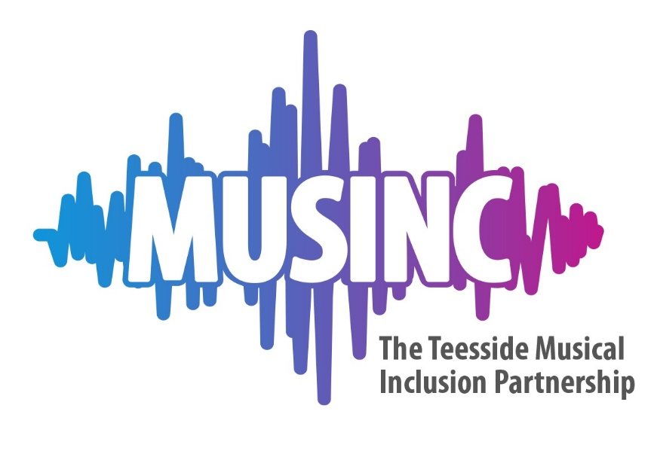
“How To” Guide:
Writing a risk assessment
Contents
Introduction and notes
Five steps to risk assessment:
- Step 1. Identify the hazards
- Step 2. Decide who might be harmed and how
- Step 3. Evaluate the risks and implement control measures
- Step 4. Final checks and sign off process
- Step 5. Review and update if necessary

Introduction
Risk assessments are an essential part of delivering any activity. When managing health and safety, you, as self-employed workers, must put arrangements in place to adequately control the risks within your workplace, as much as is practicably possible. Musinc music leaders are responsible for carrying out suitable and sufficient risk assessments for your own activities. To do this, you need to think about what might cause harm to yourself and others, and decide whether reasonable steps are in place to prevent harm. This is known as a risk assessment and is a requirement by law, under the Management of Health and Safety at Work Regulations 1999.

Your risk assessment should form the basis of your lesson/session planning, be part of the culture of your practise as a music leader, and at the heart of your delivery. Musinc exist to support you to do this so please contact us if you require additional support.

What is a risk assessment?
- Is a systematic process of identifying hazards in your setting and space.
- Will identify how to mitigate (avoid) the hazard occurring and reduce overall risk.
- Outlines how you would respond if the hazard occurs.
- Identifies hazards which are so significant they would prevent activity from taking place.
The process of completing a risk assessment ensures that all significant hazards are identified and control measures implemented to reduce the risks of injury to as low a level as is reasonably practicable.

Who should be a risk assessor?
Within a company or organisation with employed staff, it should be a competent person who has the necessary skills, knowledge and experience to assess the risks associated with the activity being assessed.For Musinc activity we are contracting you, as self-employed workers to carry out activity, and therefore it is your responsibility to complete risk assessments for your Musinc work.

Suitable and sufficient
“Suitable and sufficient” means that when you complete a risk assessment, you are expected to take reasonable steps to identify all the hazards, introduce suitable controls in order to reduce the risk of injury to an acceptable level. This may require some input from other people who have more experience and knowledge about the task or activity. However, trivial or ‘life in general’ risks need not be assessed.

What is reasonably practicable?

Direct extract from HSE: “‘Reasonably practicable’ is a narrower term than ‘physically possible’ … a computation must be made by the owner in which the quantum of risk is placed on one scale and the sacrifice involved in the measures necessary for averting the risk (whether in money, time or trouble) is placed in the other, and that, if it be shown that there is a gross disproportion between them – the risk being insignificant in relation to the sacrifice – the defendants discharge the onus on them.”

In essence, it is about weighing the risk against the requirement needed to further reduce it.
For example, if young people are performing on a stage which is quite high from the ground, the hazard is a performing at height, and the risk is that young people might fall off the front of the stage. It would be ‘physically possible’ to construct a barrier at the front of the stage, however it is not ‘reasonably practicable’ and therefore a more suitable control measure would be to use hazard tape as a visual barrier and lay the tape at a safe distance from the front of the stage.
Definition of hazard and risk

A hazard is something with the potential to cause significant harm.
A risk can be defined as the likelihood of harm occurring together with the severity

5 steps to risk assessment

This risk assessment guide is based on the five steps to risk assessment approach recommended by the Health and Safety Executive (HSE):
Step 1: Identify the hazards.
Step 2: Decide who might be harmed and how.
Step 3: Evaluate the risks and implement control measures.
Step 4: Final checks and sign off process
Step 5: Review your assessment and update if necessary.

Step 1. Identify the hazards
The risk assessment process should identify all foreseeable hazards associated with the activity being assessed. A hazard is something with the potential to cause significant harm.
In addition to general health and safety, we now must consider COVID specific safety measures, as well as other specific hazards that relate to the delivery of the Musinc programme, and therefore it is helpful to group the hazards into categories as follows:

General health and safety | COVID safety | Safeguarding | Online working
Slips, trips and falls | Prevention of spread of infection including:  - - Infected people attending sessions  - - Social distancing  - - Enhanced Hygiene procedures  - - Use of instruments and equipment in particular microphones  - - Cleaning of instruments and equipment  - - Singing and woodwind/brass activities | Disclosures | Safeguarding online including:  - Disclosures  - Working 1:1 and adult supervision
Manual handling |  | Working 1:1 with young people
Fire hazards |  | Young people in distress
Chemical and biological hazards |  | Physical contact
Electrical hazards |  | Travelling with young people | Professional appearance
Lone working hazards |  | Disruptive and/or challenging behaviour | Communication (general)
Noise and vibration hazards |  | Communication with young people
Assessing the risk
Tackle the most ‘Significant risk’ first. Consider the following:
- How serious is the risk (potential of injury?)
- Who and how many are exposed to the risk?
- How likely is it to occur?
- ‘Significant Hazard’ – Hazards which might pose serious risk to staff, (members of the public) or others, who might be affected by the work activities, if they were not properly controlled.
Step 2. Who can be harmed?

The risk assessment should also identify who could be harmed and how. This should be documented within the risk assessment using the following groups of persons:
- E - Employees. (In Musinc’s work this means other music leaders and any other staff involved in delivery of the activity)
- SU – Service Users. (in Musinc’s work this means participants of sessions)
- VP - Vulnerable Persons.
- V - Visitors.
- P - Members of the Public.
- C - Contractors.
- ES - Emergency Services.

- Think about how people involved in your activity might be harmed. Ask your colleagues and participants what they think the hazards are, as they may notice things that are not obvious to you and may have some good ideas on how to control the risks.
- For each hazard you need to be clear about who might be harmed; it will help you identify the best way of managing the risk. That doesn’t mean listing everyone by name, but rather identifying groups of people (e.g. ‘people working in the venue’ or ‘passers-by’).
- In each case, identify how they might be harmed, i.e. what type of injury or ill health might occur.
- For example, “venue technicians and music leaders may suffer back injuries from lifting and moving heavy musical equipment.”

Step 3. Evaluate the risks and implement control measures

A risk can be defined as the likelihood of harm occurring together with the severity. Once the hazards and associated control measures have been identified, the risks need to be rated. The numerical risk matrix table within the risk assessment template can be used to calculate the overall risk rating, by multiplying the relevant numbers assigned to both the likelihood and the severity of each hazard identified.
Once the overall risk rating has been calculated, the person carrying out the risk assessment must decide if any additional control measures are required to control the risks.

Control Measures
When considering new or additional control measures, you must ensure the alternative is safer than the original control.
Examples of ‘Control measures’

- Safe systems of work e.g. storing heavy items on bottom shelves and lighter items on higher shelves
- Written procedures e.g. safeguarding policy in place
- Equipment maintenance. E.g. PAT tests for electrical equipment
- Guarding. E.g. locking spaces that aren’t being used
- Training requirement (Competent/qualified). E.g. safeguarding, manual handling, first aid
- Boundaries/Marked areas for vehicles & people. E.g. stages and performance areas
- Housekeeping (Cleaning). E.g. safe storage of instruments
- Supervision. E.g. appropriate staffing levels
- Personal Protective Equipment (PPE) – this will probably not be relevant for most of your activities unless in relation to COVID-19 safety.
- Signage. E.g. in relation to COVID.

When trying to identify the existing control measures remember that they can be broken down in 3 ways:-
1. Physical controls (e.g. stacking chairs/tables safely out of the way for activities which involve movement around the space).
2. Procedural controls (e.g. a safe working procedure for the task).
3. Behavioural controls (e.g. adequate supervision and monitoring of behaviour).
Probability key | Severity Key | Calculation | Risk rating
1 = Very unlikely  2 = Unlikely  3 = Possible  4 = Likely  5 = Very likely | 1 = Extremely low (trivial injury)  2 = Low (minor injury)  3 = Medium (lost time injury)  4 = High (specified injury)  5 = Extremely high (fatality) | Probability x severity | 1 – 5 = Low risk  6-12 = Medium risk  15-16 = High rsk  20 – 25 = Extremely high
The numerical risk matrix table can be used to calculate the overall risk rating, by multiplying the relevant numbers assigned to both the likelihood and the severity of each hazard identified.able within the risk assessment template can be used to calculate the overall risk rating, by multiplying the relevant numbers assigned to both the likelihood and the severity of each hazard identified.

Step 4 – Final checks and sign off process

Once you have completed your risk assessment, you will need to:-
- Name the risk assessment and what task/activity and risk it covers.
- Ensure that the hazards and controls are clearly documented.
- Consider all those people who could potentially be harmed.
- Make sure that the completed risk assessments are fully communicated and signed off for those who need them.
Due to COVID-19 and the need for stricter risk assessment procedures, Musinc have put in place additional sign off requirements for your risk assessments. For any face to face activity, Musinc will need to sign off all risk assessments. The lead music leader is responsible for ensure that the control measures are in place and are being followed.
Please see the Musinc Health and Safety Policy for what to do in the case of non-compliance.
- Save your risk assessments somewhere easily accessible to you, as you might need these to be readily available to auditors for your business.

Step 5. Review and Update your risk assessment

Few workplaces stay the same. Sooner or later, you will bring in new equipment, substances and procedures that could lead to new hazards. So it makes sense to review what you are doing on an ongoing basis, look at your risk assessment again and ask yourself:
- Have there been any significant changes?
- Are there improvements you still need to make?
- Has anyone spotted an additional problem?
- Have you learnt anything from accidents or near misses?

Make sure your risk assessment stays up to date
Some additional useful notes on completing your risk assessment:
- In the Music handbook you will find policies for health and safety, safeguarding and online working, as well as the new COVID-19 safety guidelines. These exist as guidance for the things that you need to consider when writing your risk assessment. They do not provide the answers – they help to you consider the questions.
For example, you may be planning to deliver singing activities within your session. This needs to be included in your RA as there is possibly a higher risk of transmission of the virus through singing. Therefore, to address this in your risk assessment you would use the COVID guidance notes in this way:

Identified Hazards | Hazard Effect | Who could be harmed? | Existing control measures  (taken from the COVID-19 guidelines) | Residual risk rating
 |  |  |  | Likelehood | Severity | Overall risk
Singing | Catching COVID-19 virus through singing activities | E, SU, VP | - Singers will be at least 3m apart when singing  - There will be 3-5 metres between the leader and participants.  - We will sing outdoors if possible, and away from direction of the wind  - Doors and windows open for indoor singing  - Singers will stand side to side or back to back. | 2 | 2 | 4

- When completing risk assessments please take into consideration the potential for data protection breaches when communicating completed risk assessments to others.
- Please avoid naming specific individuals within risk assessments, where the information is likely to be shared with others.
- For individuals who are at an increased risk of COVID 19, Musinc can carry out individual risk management plans for those individuals if required by the individual.
- Confidentiality must be maintained at all times and assessments containing sensitive personal information must not be circulated to others

