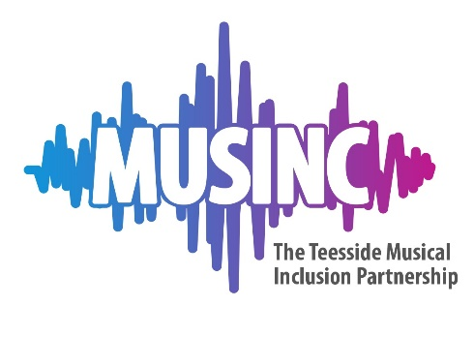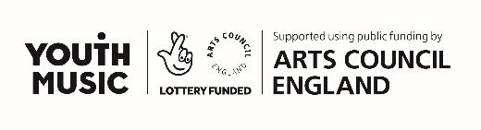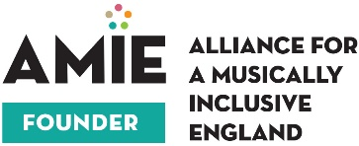

MIDI – Music Industry Development Initiative

Application form

Please briefly outline your musical background
This could be through making music but could also be your interest and involvement in music in other areas

What kind of music related role are you most interested in? e.g. marketing, technical, project management etc

What skills would you like to develop?

Do you have any previous experience of working in your chosen area of interest?
Previous experience is not essential, we need to understand your learning requirements to best support your development.

Please briefly outline why you are applying for a place on the mentoring programme

What qualities do you see in yourself that would be useful in your chosen area of interest?

Do you have an existing role within a music related profession?

Yes/No
If yes, please give details

(Optional question)
In your opinion do you face any barriers or challenges in pursuing a career in music?
Musinc are interested in any issues you may be facing that may make it more difficult for you to access career development opportunities.

Do you have any travel or access requirements?

____________________________________________________________________________

Deadline for applications
All applications are to be received by 12 noon Friday 9nd October 2020.

Please email this application form to musinc@middlesbrough.gov.uk

MUSINC recognises and promotes Equality law’s reasonable adjustments guidelines, and therefore reasonable adjustments are available. If you would like to discuss reasonable adjustment options, please do not hesitate to contact us at any point in the application process.
If you require support with your application or require this form in an alternative format, please contact us to discuss further.

